PURPOSE

This experiment aims to teach us that the results of the measurements we make cannot be completely precise, as well as to teach us that there are margins of error in the measurements we work with depending on the precision of the measuring instruments and how we can reflect these margins of error in the data.
THEORY

A List of Materials
- A rectangular prism
- A cylinder with holes
- Data sheet
- Caliper
- Ruler
- Weighing scale

In this experiment, we study measuring and calculating. We first learn how to use caliper and weighing scale. First we need to introduce some technics and formulas that are necessary to doing precise measurements and calculations. The first technic is calculating margin of error. The margin of error is the small deviations that may occur in measurements because of mechanical limitations of the measuring device. there may be a difference between the measured value and the actual value, it depends on the accuracy of the device. This difference can affects the measurement accuracy. When calculating the margin of error of an instrument, we must first find the smallest unit of measurement of the instrument, because the margin of error of the instrument is half of the smallest unit. the result of the measurement is written by the maximum possible error using the symbol “±” followed from the value observed from the scale.

We use the quantities and their units that are introduced at the Table 2
Table 1. Fundamental quantities and their units
Base Quantity | SI Base Unit | Symbol
Length | meter | m
Mass | kilogram | kg
Time | second | s

We can continue with our measurement instruments. First we use ruler for measuring dimensions of the rectangular prism and cylinder. However, we can not measure the holes depth via ruler. Therefore, we have to use caliper for measuring the depth and for measuring more precise than ruler.

Figure 1. Measuring the length of a pencil using a ruler.
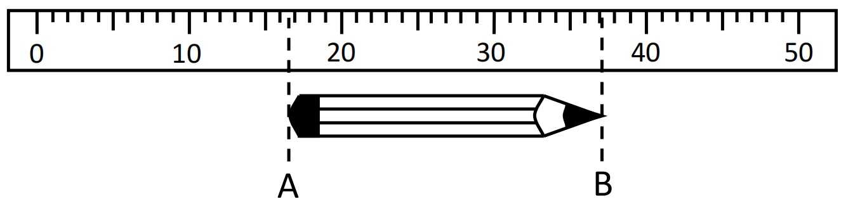
The margin of error of this ruler is 0.1 cm but each position has its own tolerance so we need to multiply it by 2.
L ± ΔL =(37-17) ± 0.2cm = 20 ± 0.2 cm

We cannot calculate these measurements as normal numbers because we have to take into account the margin of error.We need to introduce some formulas to calculate measurements.

For addition:
R ± ΔR = (x ± Δx) + (y ± Δy) = (x + y) ± (Δx + Δy)
For subtraction:
R ± ΔR = (x±Δx) - (y±Δy) = (x - y) ± (Δx + Δy)
Error in the result is the sum of the errors in the quantities.

For multiplication:
R ± ΔR = (x±Δx) ⋅ (y±Δy) = x ⋅ y ± x ⋅ y ⋅ $\left(\frac{∆x}{x}+\frac{∆y}{y}\right)$
For division:
R±ΔR = $\frac{(x ± ∆x)}{(y ± ∆y)}$ = $\frac{x}{y}$ ± $\frac{x}{y}\left(\frac{∆x}{x}+\frac{∆y}{y}\right)$

